Assignment: Create a batch file

Batch File Code:

@echo off

:: Step 1: Create a folder named EmployeeSetup on the Desktop

mkdir "%USERPROFILE%\Desktop\EmployeeSetup"

:: Step 2: Navigate into the EmployeeSetup folder

cd /d "%USERPROFILE%\Desktop\EmployeeSetup"

:: Step 3: Create three subfolders named Docs, Images, and Scripts

mkdir Docs Images Scripts

:: Step 4: Create a text file in the Docs folder named Welcome.txt with a welcome message

echo Welcome to the company! > Docs\Welcome.txt

:: Step 5: Append additional text to Welcome.txt

echo We're glad to have you on the team. >> Docs\Welcome.txt

:: Step 6: Move the Welcome.txt file to the Scripts folder

move Docs\Welcome.txt Scripts\

:: Step 7: List all files in the Scripts folder and save the output to a new file named FileList.txt

dir Scripts > Scripts\FileList.txt

:: Step 8: Retrieve system information and save it to SystemInfo.txt in the Docs folder

systeminfo > Docs\SystemInfo.txt

:: Step 9: Pause execution for the user to view the output

pause

:: Step 10: Echo a completion message to the screen

echo Employee setup script completed successfully!

Explanation of Each Step:

Explanation of Each Step

**Create EmployeeSetup folder**

**Uses mkdir to create a directory on the user's desktop.**

**Navigate into the folder**

**Uses cd /d to change directory to the new folder.**

**Create subfolders**

**Creates Docs, Images, and Scripts folders inside EmployeeSetup.**

**Create Welcome.txt with a welcome message**

**echo is used to write the first message to Welcome.txt.**

**Append to Welcome.txt**

**>> appends a second line to the same file.**

**Move the file**

**move transfers Welcome.txt from Docs to Scripts.**

**List files in Scripts and save to FileList.txt**

**dir lists all files and saves output to FileList.txt.**

**Retrieve system info and save to Docs**

**systeminfo command writes system data to SystemInfo.txt.**

**Pause execution**

**pause lets the user read the terminal before it closes.**

**Display a completion message**

**echo prints a final message confirming completion.**

Screenshots:

Screenshot the execution of the batch file in Command Prompt.

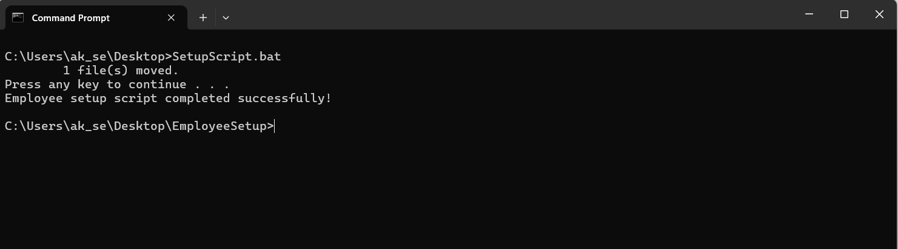

Screenshot the folder structure and files to show that the tasks were completed correctly.

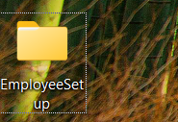

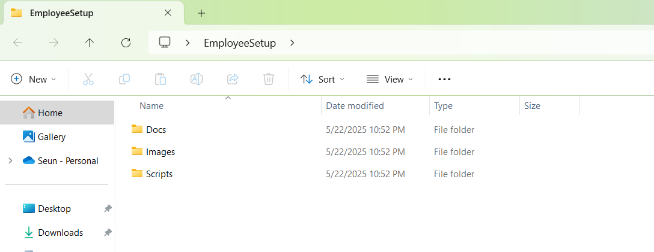

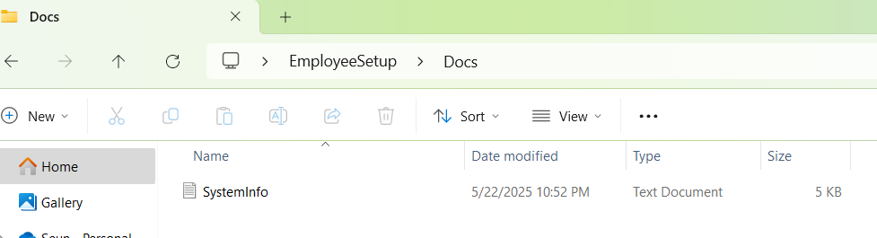

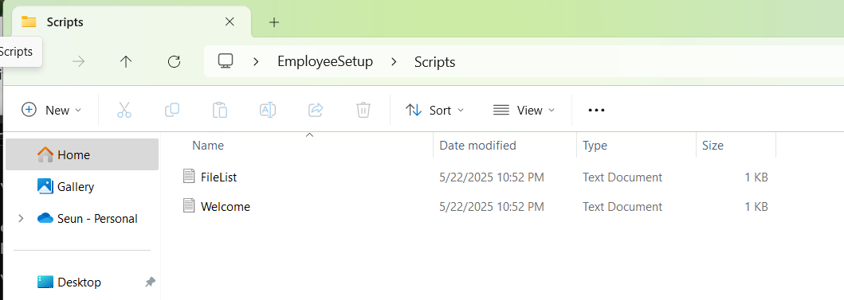

Short Reflection:

This exercise helped me understand how to automate repetitive tasks using batch scripting. I learned how to manipulate files, directories, and system information using simple but powerful commands.